MED D - Test Claim - Editing

Process
Related Documents

Description: This document provides instructions on how to edit a Test Claim in PeopleSafe.

Process

Perform the steps below:
Step | Action
1 | Select the checkbox next to the drug name.  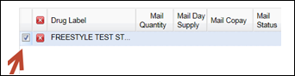  Result: Displays the original criteria entered for the drug.  Note: Upon changing the date of fill, then do not select the radial box, instead update the Fill Date field of the test claim and click Run Test.
2 | Make the necessary changes to day supply, quantity, May Sub field, etc. under the Selection Criteria.
3 | Update as needed the Optional Criteria.  - Transition Fill  - MED B  - Compound  - Fill Date  - Direct Sales (Do not use, refer to: MED D - Caremark Direct/Direct Sales)  Note: Do NOT enter the Prescriber Name field. This field will allow test claims to be performed for beneficiaries who are locked into using a specific prescriber. This new functionality is currently only being used by one client.
4 | Click Edit Drug in order to replace the previous Test Claim criteria. Otherwise, the system treats it as another Test Claim being added to the list (Reminder: Three is the limit).  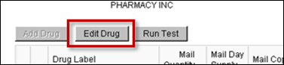  Result: Clears the previous Test Claim results for that drug and adds the updated criteria to the table.
5 | Click Run Test button.  Result: Test Claim re-runs with the new criteria.

Top of the Document

Related Documents
MED D - Test Claim Index

Parent SOP: CALL-0048: Medicare Part D Customer Care Call Center Requirements-CVS Caremark Part D Services, L.L.C.
Abbreviations/Definitions: Abbreviations / Definitions

Top of the Document
Not to Be Reproduced or Disclosed to Others without Prior Written Approval
ELECTRONIC DATA = OFFICIAL VERSION – PAPER COPY – INFORMATIONAL ONLY

